Dear Friend of Heart,
The American Heart Association will be holding the Go Red for Women Luncheon Experience on Thursday November 2^{nd,} 2017 at the Hilton Scranton and Conference Center. This year our incredible Pursenality Auction will be a part of this empowering luncheon. We hope that you will not only be able to join us for an afternoon filled with education and inspiration, but also donate a bag that represents you and your pursenality!

As an influential and well-respected person in our community, we ask you to join us Auction as someone that will be highlighted at our luncheon in the Pursenality auction. We would be honored to have your “Purse”nality package helping to raise dollars that will go towards the life-saving research and education for women and heart disease. What a fun and unique way to give back and make a difference!
As a Pursenality donor you will participate in the auction by donating a customized purse or bag package reflecting your own pursenality. All purse and bag packages will be displayed at the pursenality event and open for silent auction.
- Choose a new purse or bag that reflects your personal style.
- Fill the purse or bag with items that reflect your personality and interests.
- A short bio and photo of you will be displayed with your package- these will be collected no later than October 16th, 2017.
- Each package (purse/bag and contents) should be valued at a minimum of $150.
- Packages will be collected no later than October 20th, 2017– you have plenty of time to create your masterpiece.
Please Note: Alcohol may not be put in your silent auction purse or bag.
Attached is the commitment form. Please fill out and return by October 2nd, 2017.
Warmest Regards,
Tara Sokola
Special Events Director

Check out ideas from our other pursenality events
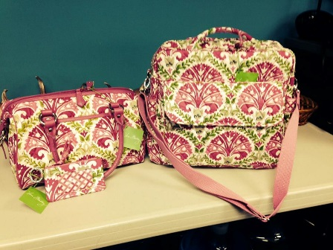
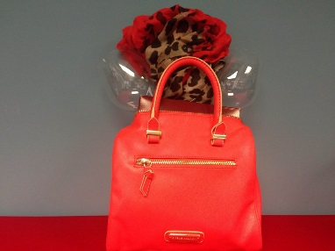
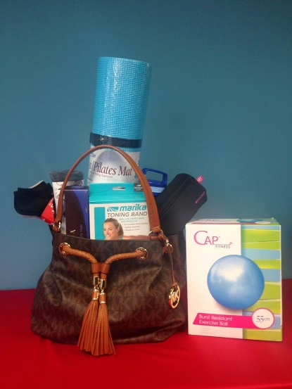

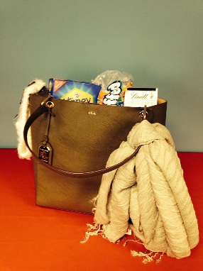
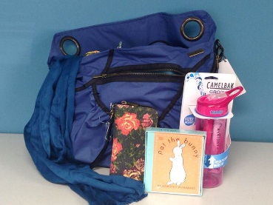
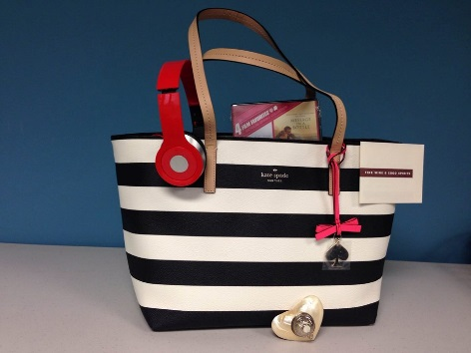

- - - - - - - - - - - - - - - - - - - - - - - - - - - - - - - - -
“Purse”nality Commitment Form
Name:_____________________________________________________
Address:___________________________________________________
Phone Number:_____________________________________________
Email Address:______________________________________________
□ Yes, I would like to donate a purse or bag package valued at $150 or more to Northeast Pursenalities.
Commitment Form Due: October 2nd, 2017
Email or Mail:
Tara.Sokola@heart.org
968 Postal Road, Suite 110
Allentown PA 18109
Questions? Please contact:
Tara Sokola
Tara.Sokola@heart.org
570-430-2391

